# **Commercial Skipper (ComSkipper) Plugin for Emby**



This plugin will work with EDL files generated by Comskip, ShowAnalyzer or any other application capable of generating them to automagically skip past commercials when playing back recordings in Emby. A visual localized notification will be presented on the screen when this happens.

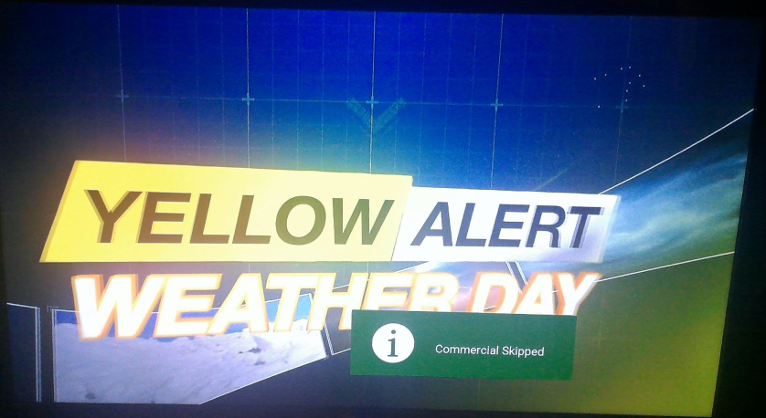

After the ComSkipper plugin is installed on the Emby server in the normal way, every time a recording is started and there is a EDL file for the recording in the same directory as the .ts file, the commercial areas defined in EDL file will automatically be skipped. So, for example if there is a recording file

*C:\Recordings\Star Trek Discovery S04E02.ts*

the corresponding EDL file would be

*C:\Recordings\Star Trek Discovery S04E02.edl*

How the EDL files get created is up to the server owner. I use comskip (note that the donator version of comskip is required as Emby records as .ts files) on a Windows server, so I created the following batch file and put it in my comskip directory.

*set drive=%~d1*

*set folder=%~p1*

*set filename=%~n1*

*c:*

*cd\comskip*

*comskip --ini=comskip.ini "%drive%%folder%%filename%.ts"*

*%drive%*

*del "%folder%%filename%.log"*

*del "%folder%%filename%.logo.txt"*

*del "%folder%%filename%.txt"*

Then I added this batch file to the Emby recordings post processing configuration.

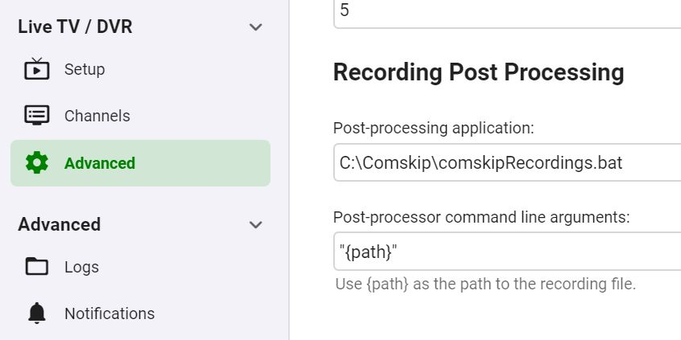

This will run comskip automatically after every recording at an average priority. It generally does not take very long to complete and have the EDL file created. If you don’t have a strong server, or have a lot of users, you might want to add the -n switch. This tells comskip to “play **n**ice” and run at a below average priority to not interfere with normal operations of the Emby server. On my server, it takes roughly the same time for comskip to process the recording as the recording length in nice mode. So, for a 30 min show, the EDL file and therefore the ability to skip commercials on playback will be about 30 minutes after the recording has completed.

I run with the standard comskip.ini file that comes with donator comskip and it does an admirable job on all my recordings that I have tried so far. However, it is not perfect. The physical recording file *is not altered at all*, the commercials are just being skipped. So, for example if ComSkipper skips too far ahead and past part of the show, simply rewind back to the actual end of the commercial. Once ComSkipper skips a commercial, it will not skip it again unless you restart playback of the recording. You could manually edit the EDL file if you wish to make a correction for future views of the recording.

As was stated earlier, the text displayed on the screen when a commercial is skipped is localized. However, there is no current way in Emby to determine the locale of the Emby client. So, the configured locale (Language) of the Emby server is used to determine the language of the on-screen text displayed. When Emby adds the ability for plugins to determine client locale, the code can be changed to use that instead.

There are some translations in place now, however I used Google Translate for all non-English ones. If your language is missing (you will see US English on-screen), or if the text you see is not correct in your language, follow these steps:

1. Turn on Debug Logging on the Emby server.
2. Restart the Emby Server.
3. After a few minutes, turn off Debug Logging.
4. Look in the latest embyserver log for a line that starts with:  
   Com Skipper: Locale =
5. In the Emby forum post in the ComSkipper thread in plugins that contains that line in the log and what the text should be in your language. In US English it’s “Commercial Skipped”.

I will add your addition/correction to the next release of the plugin.

The only configuration item for this plugin in an enable/disable switch.

That’s it, enjoy commercial free recordings!

This plugin is completely free. If you find it of value and have the means, please consider donating to a local charity that benefits children.